2017081617L56 _pose_estimator.py : estimate()

First step: locates persons
Debug watch:
import matplotlib; matplotlib.pyplot.imshow(image); matplotlib.pyplot.imshow(hmap_person, alpha=0.5)

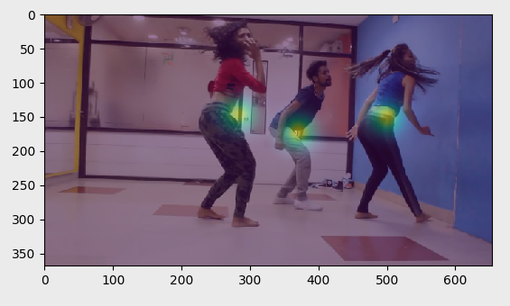
heat focus on each person

import matplotlib; matplotlib.pyplot.imshow(_hmap_pose[0,:,:,0]);

Debug view for subplots;
import matplotlib; [(matplotlib.pyplot.subplot(4, 4, i+1), matplotlib.pyplot.imshow(_hmap_pose[0,:,:,i])) for i in range(15)];

_map_pose content for #0

